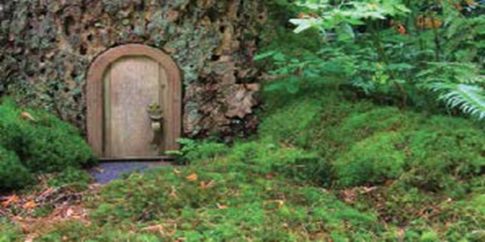
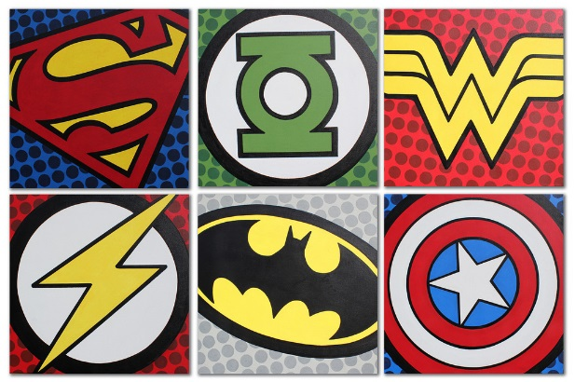
Year 1 Learning Log – Summer 1
The grid below shows activities around Year One’s topic of ‘Enchanted Woodland.’
Homework is due back on Monday 11th May 2020

The key skills children will be developing:
Research: Finding out about artists and the world’s trees and forests using the internet and books.
Literacy: Writing stories, poems and riddles.
Mathematics: Exploring measurement and sequencing the months of the year.
Science: Making observations of plants, gathering data and evaluating growth.
Creative: Developing and exploring joining techniques to create natural sculpture and artwork.

Design and Make  - Make a natural sculpture or picture using materials from your garden or a local park such as twigs, leaves and moss.  - Make a mini home for a fairy or elf using natural materials such as bark, twigs, leaves, pebbles and pine cones. Decorate using beads and glitter!  - Have fun building a den with family and friends! Use as many natural materials as possible. Take a photograph to share at school.  - Build a bird’s nest using natural materials. | Creative Writing  - Write a ‘Who am I?’ riddle for family and friends to solve. Write clues about a woodland animal, plant or tree.  - Write a pebble poem! Choose lots of flat, smooth pebbles and write one word on each to make your poem.  - Write a story about someone who finds something in a magical woodland.  - https://www.wikihow.com/Make-Fairy-Dust  - Use these instructions to make your own fairy dust. Write about how you would use the fairy dust you have made. | Research  - Search the internet or visit your local library to find out about artists famous for their natural sculpture or use of woodland as inspiration e.g.: Andy Goldsworthy. Can you create a non-fiction book about their work?  - Search the web for images and facts about amazing woodlands and forests around the world. Make a scrapbook showing your favourite ones.  - Make a non-fiction book of amazing trees. Research what the world’s oldest and tallest trees are and where they can be found.
Fun Maths  - Measure the length or height of small trees or bushes, sticks, twigs and leaves found in your garden or a nearby park. Draw pictures and write the measurements down beside them.  - How many woodland treasures can you fit in a matchbox or raisin box? Make a tally chart of what you’ve included.  - Write the months of the year in order and write down what flowers/trees grow at these times.How big was the brain of a T-Rex? | Wider World  - Take your family for a woodland walk – Black Park or Burnham Beeches, would be great! Take photographs of interesting leaves, flowers and trees and make a book. Draw a map of the route you took.  - Go on a tree hunt. Can you show an adult coniferous (evergreen) and deciduous trees? Tell your family what these words mean.  - Visit a garden centre and choose some seeds to plant. Take photographs of the plant’s progress. | Be a Scientist  - Plant some flowers or vegetables. Draw and write a diary detailing the changes you see as they grow. What happens if you take away light and/or water from one? Can you explain why?  - Make observations of plants and trees changing as we head from spring into summer. What’s happening? Why? Write a report or create a book detailing your observations. Include pictures, photographs and measurements.

