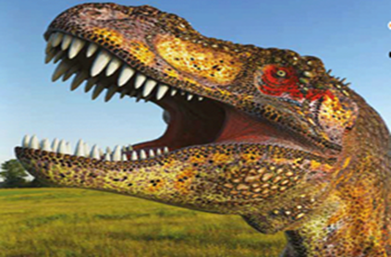
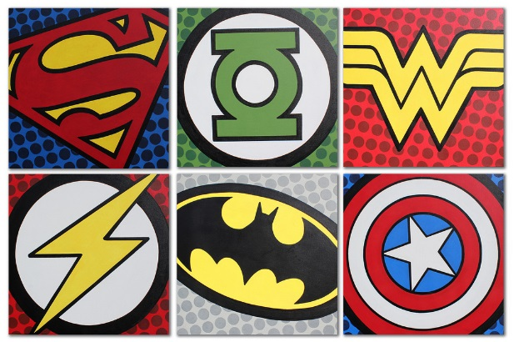
Year 1 Learning Log – Spring 2
The grid below shows activities relating to Year one’s topic of ‘Dinosaur Planet’.
Homework is due back on Monday 23rd March.
The key skills children will be developing:
Research: Finding out a range of information from the internet and other sources.
Literacy: Writing labels, captions and information texts; reading a range of different texts.
Mathematics: Exploring and finding similarities and differences, fact finding.
Science: Carrying out egg experiments and recording the results.
Creative: Developing and exploring a wide range of art and design techniques to represent their experiences.

Design and Make  - Create a model of a dinosaur using junk materials found at home.  - Create your own dinosaur! What does it look like? What is it called? Design it on paper first, and then make it using junk materials, clay or lego.  - Create your own fossil or imprint of a fossil using salt dough. Here’s a recipe you can use: https://www.bbcgoodfood.com/howto/guide/how-make-salt-dough-recipe | Creative Writing  - Choose a dinosaur and make your own fact page, diagram, poster, leaflet or book. Make a detailed diagram of your favourite dinosaur.  - Is there a dinosaur for each letter of the alphabet? Try to find one for each and make a list!  - Write a story about a dinosaur. Where does it live? What does it do? Where does it go?  - Choose a Dinosaur writing project from Purple Mash. https://www.purplemash.com/#tab/pm-home/topics/history/dinosaurs | Research  - Why did the dinosaurs become extinct? Research online and create a poster.  - Find out about Mary Anning. Make a scrapbook detailing her life, work and famous finds. https://easyscienceforkids.com/mary-anning/  - Find out the answers to these questions:  - Which was the tallest dinosaur?  - How heavy was the heaviest dinosaur?  - How fast could the fastest dinosaur run?
Fun Maths  - How many different species of dinosaurs were there? Can you display them in a Venn-diagram? Choose the way you’re going to categorise them: colour, diet, or even where they live1  - Find out the following information and make a poster to share your facts:  - How long ago did they live?  - When did they become extinct?  - Which was the smallest dinosaur? | Wider World  - Go to the Natural History Museum in London for FREE! What dinosaurs do you see? Take some photos of your visit and create a scrapbook.  - Visit the library and choose a variety of dinosaur books. Read them with your family. What have you learnt? Were the books fiction, or non fiction? Can you create a book report on your favourite one? | Be a Scientist  - Choose one of these egg-cellent experiments to carry out at home! Record the results in a table, by drawing pictures or by taking photographs.  http://www.science-sparks.com/2013/02/16/10-egg-science-experiments/  - Go to https://inventorsoftomorrow.com/2017/01/23/dinosaurs-2/ to find lots more scientific experiments!

