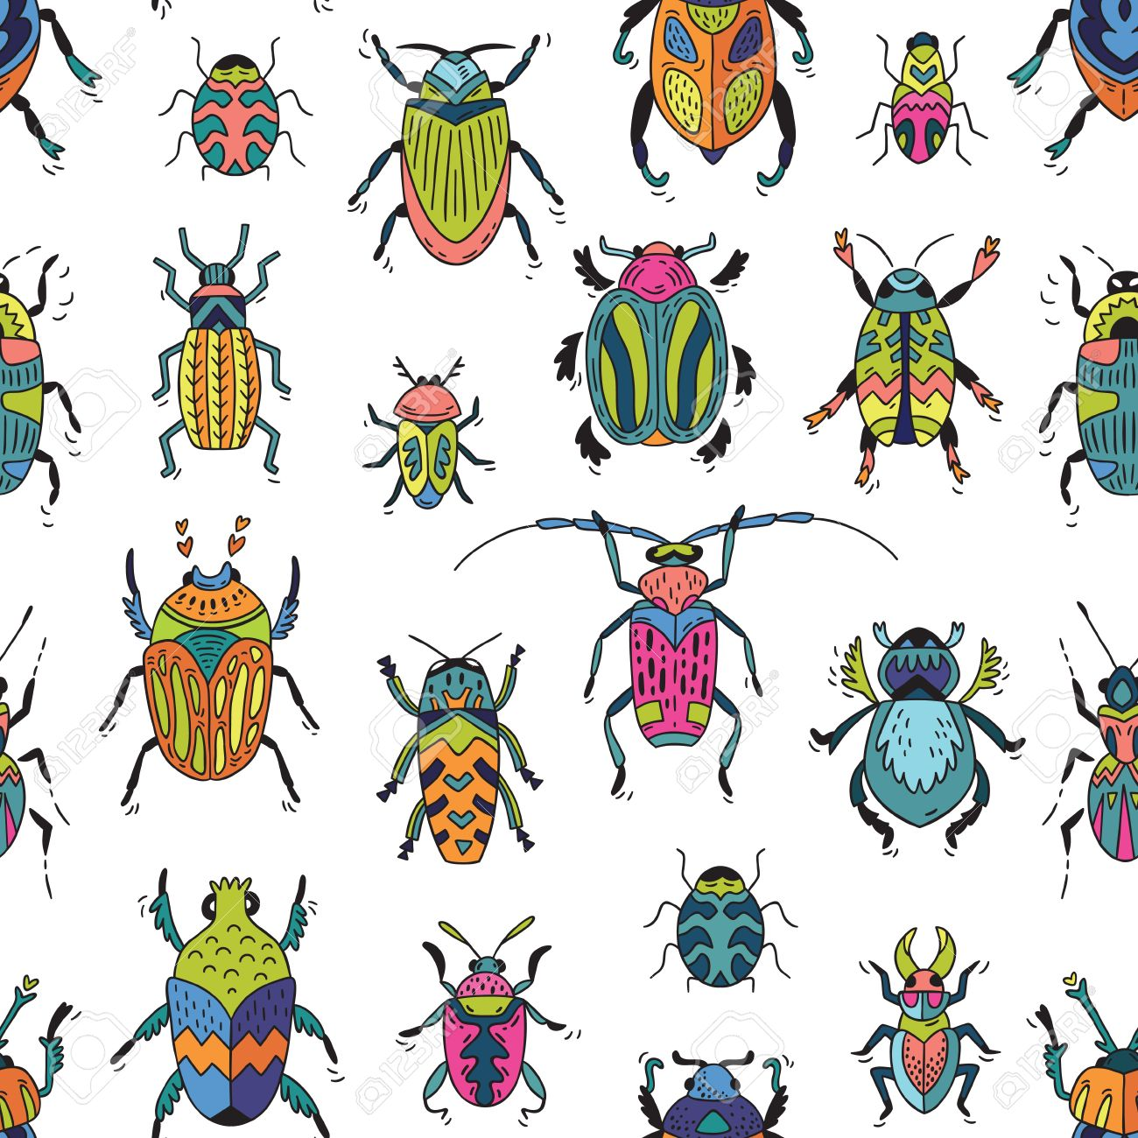

**Music**

* Explain what they like and dislike about a piece of music.
* Describe basic elements of a piece of music e.g. pace, volume and emotion.
* Describe how an instrument has been used to represent a sound or object e.g. a flute for a bird.
* Play tuned instruments (ukulele) musically.

* Emotion
* Tempo
* Instrument
* Pictogram
* Data
* Field work
* Symbols
* Key
* Non-fiction
* Fact file
* Species

* Comparison / Compare
* Similar
* Difference
* Wormery
* Natural
* Environment
* Changes
* Bees
* Bee Hive
* Local
* Extinct
* Pace
* Volume

**Vocabulary**

* Time adverbs
* Mini-beast
* Research
* Habitat
* Continent
* Country
* Ocean
* Equator
* North / South Pole
* Climate
* Vertebrate
* Invertebrate
* Venn Diagram

**Geography**

* Name and locate the world continents and oceans on a world map or globe.
* Locate hot and cold areas of the world in relation to the equator and the North and South poles and explain how the weather affects these areas.
* Describe and compare the physical similarities/differences between areas of the UK and contrasting non-European countries.
* Use i9nformation texts and the web to gather information about the world’s human and physical geography.
* Use geographical vocab to name features of familiar and unfamiliar places.
* Suggest ways of improving the local environment.
* Use given information and observations to ask and respond to questions about the environment recognising how people affect this.
* Draw simpe maps or plans using symbols or a key.
* Collect anhd organise simple data from first and second-hand sources including fieldwork.

**Knowledge, Skills and Vocabulary**

**Wriggle & Crawl**