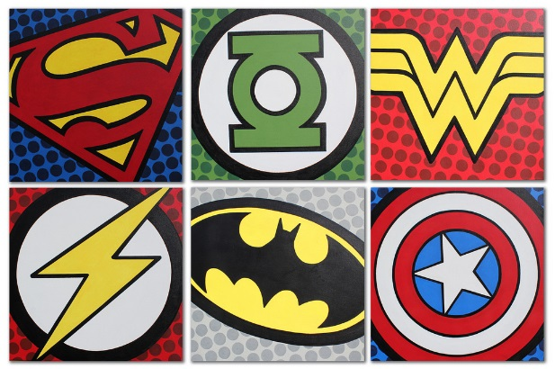
Year 2 Learning Log – Autumn 2
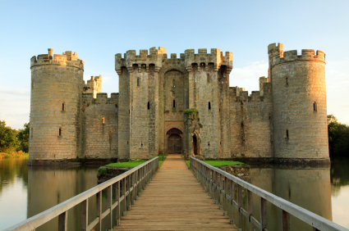
The grid below shows activities for Y2’s topic of “Towers, Tunnels and Turrets”.
Homework is due back by Monday 2nd December.
The key skills children will be developing:
Research: Finding out a range of information from the internet and other sources.
Literacy: Writing stories, poems and information texts; reading a range of different texts.
Mathematics: Fractions of an amount and shape, telling the time to the nearest 5 minutes and measurement.
Science: Exploring the suitability of different materials.
Creative: Developing and exploring a wide range of art and design techniques to represent their own world and experiences.

Design and Make  - Design and create a model of a famous structure from around the world using your recycling at home. What will you choose? The Tower of London? The Statue of Liberty? The Leaning Tower of Pisa?  - Design and create a flag which you would like to have flying above your castle. Think about what patterns you might want to include.  - Design a new landmark for Slough. What will it look like? What can people do there? Label your design. | Creative Writing  - Choose your favourite castle from a story. Write 5 descriptive sentences describing why this castle is so special.  - Make an information book about a famous castle in the world. Draw pictures and use images from the internet. Can you think of a WOW fact to share with the class?  - Write a poem about a Knight or a Princess who lives in a Castle. Draw a picture with your poem. | Research  - Choose a famous landmark in the U.K and create a poster including 5 interesting facts.  - Research a famous engineer from the U.K such as Isambard Kingdom Brunel. Draw a picture of their creations. Can you share an interesting fact about them?  - Research the Channel Tunnel. What interesting facts can you find out? Use books or the internet to help you.
Fun Maths  - Follow a recipe with an adult. Measure the ingredients to make a snack that you think would suit a medieval party in a castle!  - Play a tumbling tower game such as Jenga with your family! How many bricks tall can you can build your tower? Are there any tricks for making sure your tower doesn’t fall? Bring some photos to show your teacher!  - Create a tower using a range of 2D and 3D shapes. Can you describe the features of the 3D shapes? | Wider World  - Design a healthy menu fit for a King or Queen at a banquet. Have you included foods from every food group?  - Visit a local castle or tunnel. Take some photos and share with your teacher. What features can you see?  - Visit a local library e.g. The Curve to find out more information about castles or bridges. Create a fact file for your teacher.  - Go on a bridge hunt around the local area, taking photographs to show your class. What types of bridges have you seen? Choose the most interesting bridge and see what information you can discover about it online. | Be a Scientist  - Build towers each with one of the following materials: tin foil, toothpicks, clothes pegs or cut up card. Which one is the most stable? How do you know? Why do you think that is? Take photos and write up your observations.  - Follow the link to create construct a bridge: https://iexplorestem.org/engineering-activities-bridge-construction. Share the results with your class.  - Create a shield using the following link https://www.english-heritage.org.uk/easter/preparing-for-easter-adventure-quests/how-to-make-a-cardboard-shield/ What materials did you use to create this? Which materials would not be suitable?

