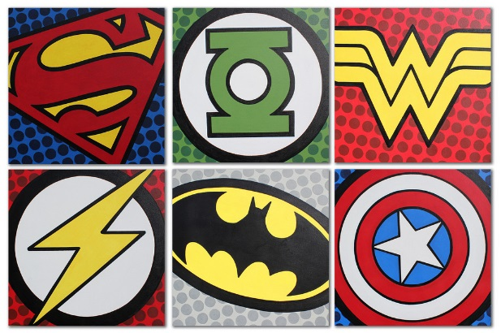
Y2 Learning Log – Autumn 1
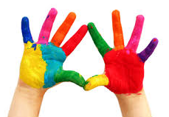
The grid below shows activities for Y2’s topic of “Muck, Mess and Mixtures”.
Homework is due back by Monday 14th October.
The key skills children will be developing:
Research: Finding out a range of information from the internet and other sources.
Literacy: Writing stories, poems and information texts; reading a range of different texts.
Mathematics: Number, addition, subtraction, partitioning and place value, multiplication and sharing.
Science: Learning about the human body including healthy eating and the effect of exercise on the body.
Creative: Developing and exploring a wide range of art and design techniques to represent their own world and experiences.

Design and Make  - Cook one of Roald Dahl’s revolting recipes and make a picture book to share. Find his recipes using the following link: https://www.roalddahl.com/create-and-learn/make/revolting-recipes  - Create a piece of artwork inspired by James Parker using left over foods you have at home. Bring it into school or take a photo to share with your friends.  - Make a clay sculpture. You could decorate this once dry using paint! What sculpture will you create?  - Make a slush drink using crushed ice and juice. Take a photo and write up your recipe for your teacher to try. | Creative Writing  - Write a poem with the title ‘Muck, Mess and Mixtures’. Include some exciting adjectives and read it aloud to the class.  - Write a recipe for your own mystical and magical potion. What ingredients will you include? What effects will your concoction have?  - Write a story inspired by witches and wizards! What adventures will your characters have?  - Read the book ‘Winnie the Witch’ by Valerie Thomas and write your own character description of a witch. Include interesting and exciting adjectives in your description. Use a thesaurus to help you use new vocabulary. | Research  - Use information texts and the internet to find out about Roald Dahl and what inspired him to write the story ‘George’s Marvellous Medicine’.  - Visit your local library e.g. The Curve to research artists who use unusual materials to create artwork e.g. food or natural materials. Can you create a scrapbook detailing their work to date?  - Research another story written by Roald Dahl. Read it with your family and write a book review. What is your favourite part of the story? Can you notice any similarities to ‘George’s Marvellous Medicine’? Use the following link to help you find a story: https://www.roalddahl.com/global/roald-dahl-titles
Fun Maths  - In the bath, use a measuring jug to measure out different amounts of water. Create a capacity challenge for your friends and bring it into school for them to try.  - Follow a recipe with an adult, measuring out the ingredients, to make a fun party snack such as those below: www.bbcgoodfood.com/recipes/collection/kids-party  - Create a collage using natural resources you have found outside. Can you use any patterns in your collage? Can you identify any 2D or 3D shapes that you may have created? | Wider World  - Visit a pottery painting shop. Choose an object to decorate, perhaps a plate or cup. Bring it into school to share!  - Go on a hunt for natural materials you find in your garden or a park – soil, leaves, bark – and make a messy potion! Write down how you made it and draw a picture of the result.  - Visit a local art gallery with your family, for example The National Art Gallery, Bygillian Gallery or The Stanley Spencer Gallery. What artwork did you like? Is there an artist which has inspired you? Share your experience with your friends in class. | Be a Scientist  - Set up a melting experiment. Take 3 glasses and fill them with the same amount of ice. Leave them in different places in your home and observe which melts first. Can you research why? Write up your experiment to share with your class.  - Compare how long it takes for sugar lumps to dissolve in warm and cold water. Record your findings for your friends.  - Investigate a range of everyday materials such as salt, wax, flour, sugar, glitter and shaving foam. Find out how much each material changes when mixed with water. Make predictions before mixing and create a table or chart to show your results.

