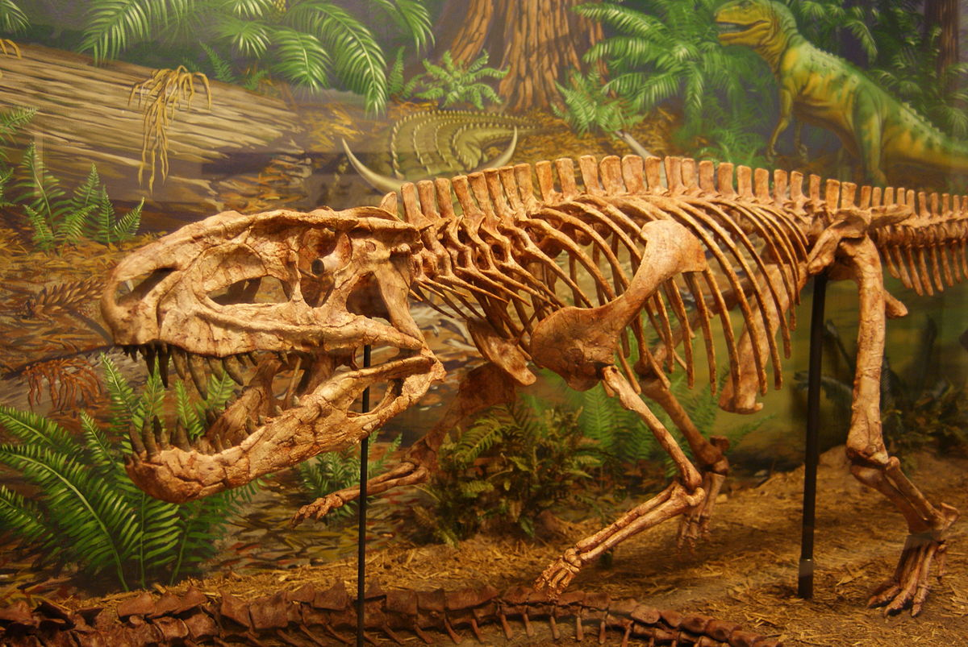

**sequence**

**significant**

**source**

**build**

**join**

**rigid**

**malleable**

**carnivore**

**herbivore**

**omnivore**

**diet**

**habitat**

**extinct**

**continent**

**Pangea**

**Europe**

**Map**

**label**

**equator**

**Vocabulary**

**Jurassic**

**Triassic**

**Cretaceous**

**Mesozoic**

**era**

**dinosaur**

**Knowledge, Skills and Vocabulary**

**Dinosaur Planet**

**Art & Design**

* **Describe the sensory properties of a range of different materials and decide which one to use when making something**

**Design & Technology**

* **Draw a simple picture of an intended design with basic labelling, using an ICT package.**
* **Select and explain why they have chosen a particular tool for a task.**
* **Select and explain their choice of materials, sometimes with help.**
* **Describe others' work, including work by professional crafts people and designers and say what they like and dislike about them.**
* **Talk about their own and others' work identifying strengths and weaknesses.**
* **Cut accurately and safely with scissors.**
* **Join appropriately, using glue or tape**
* **Build simple structures.**

**History**

* **Use simple vocabulary to describe passing of time (eg. Now, then, long ago, before and after).**
* **Use simple source material (e.g. photographs) to answer questions about an event beyond living memory.**
* **Ask and respond to simple questions about the past, using sources of information, use simple source material (e.g. photographs) to answer questions about an event beyond living memory.**
* **Sequence the life of a significant individual.**

**Important People**

**Mary Anning**

**Geography**

**Knowledge & Understanding**

* **Use maps, pictures and stories to find out about different places,**
* **Use simple locational language, including front, behind, next to, far away and near to, to describe the location of geographical features on a map and in fieldwork.**

**Practical**

* **Describe in simple terms how wind or water has affected the geography of an area. Ask and respond to questions about places/environments.**