**Knowledge, Skills and Vocabulary  
Street Detectives**

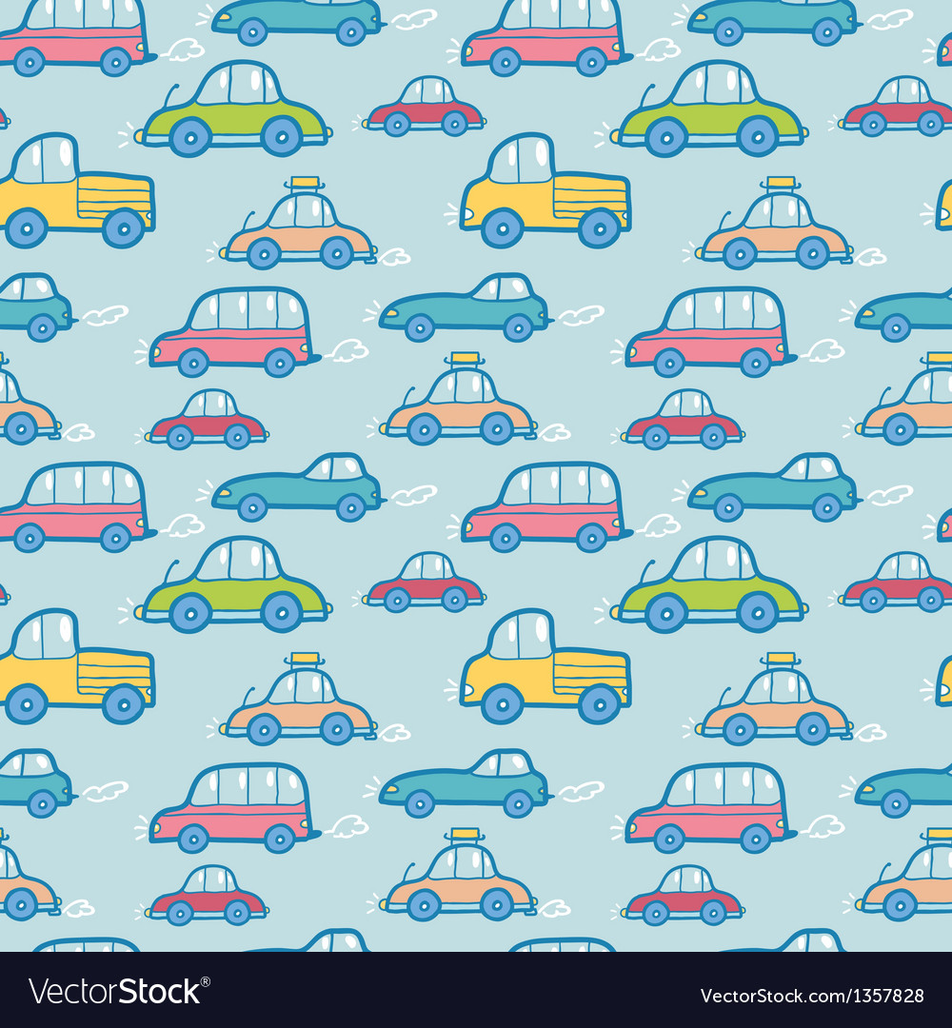

**Design & Technology**

* Produce detailed, labelled drawings or models of products based on design criteria.
* Think of ideas and plan what to do next, based on their experience of working with materials and components.
* Describe why a design, building or designer is important.
* Create simple pop ups using card.
* Use tools safely for cutting and joining materials.
* Work safely in construction.   
  **Vocabulary**Structure Investigation  
  Design Building  
  Materials Construction  
  3D Models Hinges

**Geography**

* Describe how a physical or human process has changed an aspect of the environment (e.g. the local environment).
* Explain how a place has changed over time.
* Describe how people, places and events changed in their own locality over time.
* Name, describe and compare human and physical features of their own locality and another names place, asking and responding to questions.
* Use geographical vocabulary to name features of familiar and unfamiliar places.
* Suggest ways of improving the local environment.   
  **Vocabulary**

Path Detached House Flat Building  
Street House Terraced House

**History**

* Use stories of famous historical figures to compare aspects of life in different times.
* Use further terms associated with the past (e.g. year, decade and century).
* Begin to understand cause and effect by looking at a significant individuals actions and what happens as a result.
* Describe how people, places and events in their own locality have changed over time.
* Explain how a place has changed over time.
* Describe changes in their local area during their own lifetime and that of their parents and grandparents.
* Show increased knowledge and understanding of events beyond living memory through simple recording, using text and drawings.
* Use the stories of famous historical figures to compare aspects of life in different times.
* Build a bigger picture of a historical period, using a range of source material.   
  **Vocabulary**

Research Chronological order

Past Queen

Present Carriage

History Railway   
Donate Journey

Important Figure Railway Track