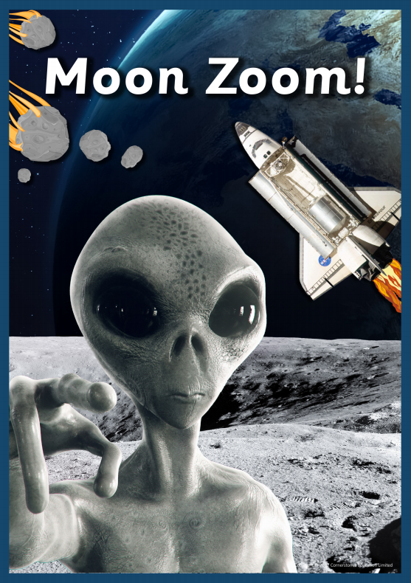

**Neptune**

**Pluto**

**planet**

**solar system**

**asteroid**

**orbit**

**dwarf planet**

**Important People**

**Neil Armstrong**

**Tim Peake**

**Christina Koch**

**Jessica Mei**

**Vocabulary**

**Mercury**

**Venus**

**Earth**

**Mars**

**Saturn**

**Uranus**

**Jupiter**

**NASA**

**International Space Station**

**rocket**

**helmet**

**space walk**

**alien**

**astronaut**

**Knowledge, Skills and Vocabulary**

**History**

* **Use simple vocabulary to describe passing of time (eg. Now, then, long ago, before and after).**
* **Use simple source material (e.g. photographs) to answer questions about an event beyond living memory.**
* **Ask and respond to simple questions about the past, using sources of information, use simple source material (e.g. photographs) to answer questions about an event beyond living memory.**

**Design & Technology**

* **Draw a simple picture of an intended design with basic labelling.**
* **Select and explain why they have chosen a particular tool for a task.**
* **Select and explain their choice of materials, sometimes with help.**
* **Describe others' work, including work by professional crafts people and designers and say what they like and dislike about them.**
* **Talk about their own and others' work identifying strengths and weaknesses.**
* **Cut accurately and safely with scissors.**
* **Join appropriately, using glue or tape**
* **Build simple structures.**

**Art & Design**

* **Describe the sensory properties of a range of different materials and decide which one to use when making something**
* **Handle and manipulate rigid and malleable materials and say how they feel**
* **Take a self-portrait or a photograph of someone else.**

**Geography**

**Knowledge & Understanding**

* **Use maps, pictures and stories to find out about different places,**
* **Use simple locational language, including front, behind, next to, far away and near to, to describe the location of geographical features on a map and in fieldwork.**

**Practical**

* **Describe in simple terms how wind or water has affected the geography of an area. Ask and respond to questions about places/environments.**