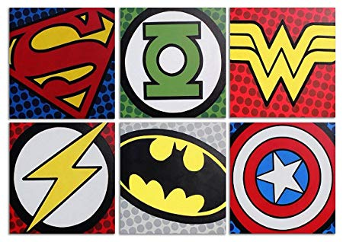
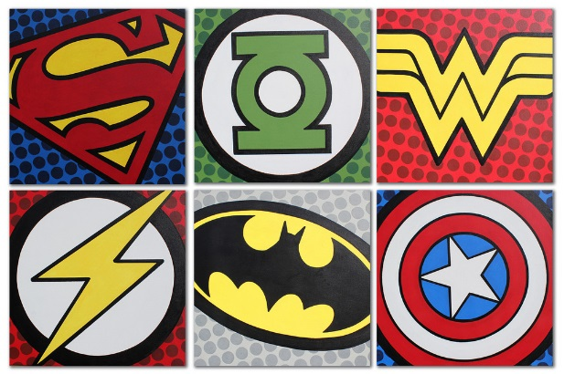
Year 1 Learning Log – Autumn 1
The grid below shows activities for Year 1’s topic of “Superheroes”.
Homework is due back by Monday 14th October.
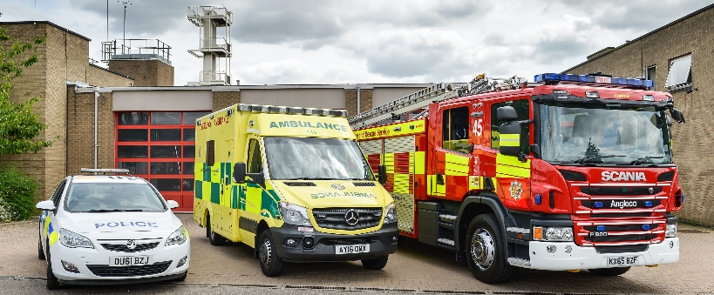
The key skills children will be developing:
Research: Finding out a range of information from the internet and other sources.
Literacy: Writing captions, stories and information texts; reading a range of different texts.
Mathematics: Exploring measurement of time, displaying information on a pictogram.
Science: Scientific enquiry, data collection and recording. Testing different materials and learning about their properties.
Creative: Developing and exploring a wide range of art and design techniques to represent their own world and experiences.

Design and Make  - Design and make a lunchbox for a superhero using junk modelling materials. Can you fill it with healthy food?  - Design a poster, on paper or the computer, featuring a new superhero such as Anti-Litterman and tell us about their important message.  - Take photos of yourself being a ‘superkid’ at home. Maybe you tidied your room or helped wash the dishes! Create a photobook to share.  - Make a model of a superhero using clay, papier-mâché or junk modelling. When you have finished, think about what went well and what you would change next time. | Creative Writing  - If you could have any super power, what would it be? Would you be able to fly, become invisible or see through buildings? Choose one and write about the adventures you could have.  - Who is your hero? Draw a picture of them and write all about who they are, what they do and why they are your hero – don’t forget to use the word ‘because.’  - Create a comic book all about your chosen superhero – use pictures, captions and sentences to tell stories of the adventures that they go on and the heroic things that they do! | Research  - Use information texts and the Internet to find out about Guinness World Record holders and their superhuman achievements. Can you make a book detailing your 5 favourites?  - Can you research some famous heroes from the past? This could include famous scientists, inventors or sportspeople. Make a book to share with your friends, telling them all about that famous hero.  - Look in a non-fiction book about everyday superheroes, then look in a fiction book about superheroes. How are the books different? How are the heroes different? Compare two.
Wider World  - Visit some of the emergency services around Slough, and interview someone who works there – such as a firefighter or a policeman/woman. Create a non-fiction text about what they do, wear and what tools they need.  - Look at the newspaper and try to find articles on real-life superheroes. This may include people who have helped someone in their time of need. | Fun Maths  - Ask your family and friends who their favourite superheroes are. Put the results into a table or create a pictogram.  - Ask someone to time you running. How fast were you? Can you beat your time the second time around? Try it with different activities too, including jumping and cycling. | Be a Scientist  - Try to be a hero like Elsa, and freeze things! Try freezing different foods and drinks to see what happens to them. Record the results by drawing and writing sentences.  - Choose one of these ‘super’ experiments to carry out at home with an adult! Record the results by drawing pictures or by taking photographs;  https://superheroscience.wordpress.com/experiments/

