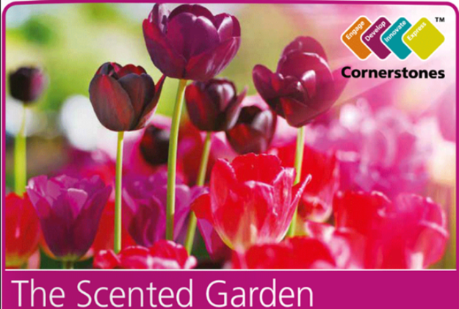
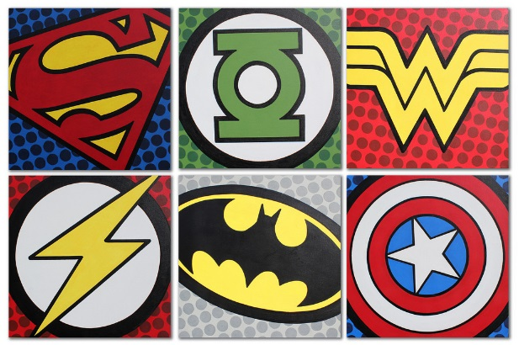
Year 2 Learning Log – Summer 1
The grid below shows activities for Y2’s topic of “The Scented Garden”.
Homework is due back by Monday 11th May.
The key skills children will be developing:
Research: Finding out a range of information from the internet and other sources.
Literacy: Writing stories, poems and information texts; reading a range of different texts.
Mathematics: Fractions of an amount and shape, telling the time to the nearest 5 minutes and measurement.
Science: Know that a seed needs water and warmth to grow (germinate).
Creative: Developing and exploring a wide range of art and design techniques to represent their own world and experiences.

Design and Make  - Can you create a collage using a variety of different leaves and flowers? Bring photos to school to show your teacher.  - Design and create a flowerpot to plant your very own flower. Use this link to help you: https://www.gardenbuildingsdirect.co.uk/blog/how-to-decorate-a-plant-pot/  - Look at the work of the artist Van Gogh. Can you create a painting in his style? Google ‘Van Gogh’ to find examples.  - Create your own outdoor 3D sculpture of something you can find in a garden or park. You could use junk modelling or clay. Bring your sculpture into school. | Creative Writing  - Keep a plant diary explaining how you have grown a plant. Include photographs or drawings of each stage of your plant’s development.  - Write a description about your favourite flower. Can you include adjectives and at least one expanded noun phrase?  - Grow a plant from a seed that you have found from a piece of fruit. Write instructions to tell someone how to plant it.  - Read ‘Jack and the Beanstalk’. Can you re-write the story changing 1 or more of the main parts, for example the location or main character? | Research  - Visit your local library, The Curve, and find non-fiction books about planting. Look for information and write down any new facts you have learned to share with your class.  - Use the following website to create a fact-file about a weird and wonderful flower! Which will you choose to research? https://www.serenataflowers.com/pollennation/unusual-flowers/  - Download and print a large image of a tree. Label each part of the tree and write what it’s for.
Fun Maths  - Create a pictogram showing how many flowers or plants you have found in your local park, woodland or garden.  - Choose some flowers from your garden, local park or woodland. Are they symmetrical? How many lines of symmetry does each flower have?  - Design your own garden! Use a variety of 3D and 2D shapes to do this. Will your design have any lines of symmetry? Will there be any patterns? | Wider World  - Grow a herb garden at home and use your herbs in some delicious recipes for your family and friends.  - On a visit to the supermarket, find and discuss plants you can eat, including herbs, vegetables and fruit. Which part of the plant are they? The roots? The leaves? The stem?  - Visit a garden centre or florist. Find out the names of any plants that you don’t recognise. What plants did you discover? | Be a Scientist  - Grow a sunflower and keep a record of its height. Who can grow the tallest sunflower in the class? Take some photos!  - Label and draw the life cycle of either a plant or a tree. Use the internet or books to help you with this.  - What plants do you find in the following countries: India, Brazil, Australia and Canada? Create a fact-file for each one.  - Use two white flowers. Place one flower in a jar mixed with red food colouring and another in a jar with clear water. Can you predict what happens? Draw/write what actually

