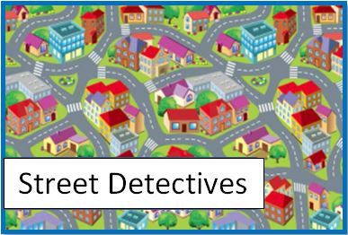
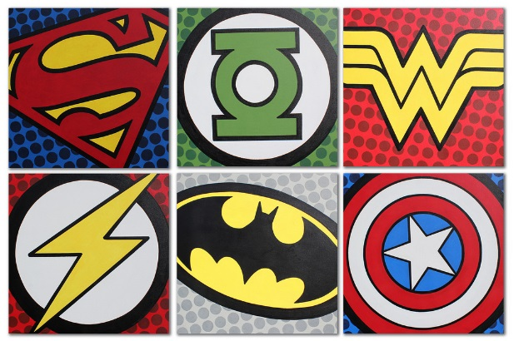
Year 2 Learning Log – Spring 2
The grid below shows activities for Y2’s topic of “Street Detectives”.
Homework is due back by Monday 23rd March.
The key skills children will be developing:
Research: Finding out a range of information from the internet and other sources.
Literacy: Writing stories, poems and information texts; reading a range of different texts.
Mathematics: Fractions of an amount and shape, telling the time to the nearest 5 minutes and measurement.
Science: Exploring the suitability of different materials.
Creative: Developing and exploring a wide range of art and design techniques to represent their own world and experiences.

Design and Make  - Draw a map of your ideal neighbourhood. Who would you like to have living on your street? You might choose fairy-tale characters, sports champions or superheroes! Create a book with a separate page for each person and their house  - Look in detail at the outside of your house and make an observational drawing. Label it and describe how it’s different/the same from other houses on your street.  - Read ‘If I Built a House’ by Chris Van Dusen and then make a fantasy home of your own using junk modelling materials! What features would it have? How many rooms? What would the garden look like? | Creative Writing  - Keep a street diary updated with all the exciting things that happen in your street. Remember to use interesting adjectives and adverbs.  - Make a leaflet about your local community. Include drawings and photographs to show what you see and do there. Write and record your thoughts on what it is like to live there as well as ideas for improving it.  - Write a short story featuring a character from your area. Create a Box Up to structure your story before writing it. Bring it in to read to your friends! | Research  - Talk to your grown-ups at home about how life was different in the past. Draw pictures and write some sentences to share at school.  - Find out about the history of the Farnham Road. What did it used to look like? What shops were there? Can you find any photos? Create a scrapbook to share.  - Interview someone who has lived in your community for a long time, for instance an elderly relative or neighbour. What changes have they seen? What things are better or worse today?
Fun Maths  - Observe the shapes on buildings in your local environment. Draw and label the building you’ve chosen.  - Visit a local shop with a grown up. Write a shopping list before you go. Pay for your shopping and see if you can work out your change.  - Create a timeline of the local area including the first road, the first shop, any places of worship and when your home was built. Draw a picture for each date and share with your friends. | Wider World  - Visit a local library e.g. The Curve to find out more information about the local area. Create a scrapbook to share with your class.  - Arrange with your family to do something good for the local community. With an adult, go litter picking in a park; help a neighbour with some shopping; or volunteer at your local place of worship. Take pictures to share with your class.  - Research homes from around the world. Create an information book to share and make one using junk modelling.  - have you seen? Choose the most interesting bridge and see what information you can discover about it online. | Be a Scientist  - Visit The James Dyson Foundation website:  https://www.jamesdysonfoundation.co.uk and click on the ‘Resources’ tab. Download the challenge cards and complete the engineering ones in orange. Can you take pictures of your experiments to share with the class?  - Observe the weather in your local area. Can you create a tally chart showing how many days were sunny, cold, cloudy, frosty, snowy and hot? What does your data tell you?  - Identify different materials items around your home and decide if they are man-made or natural. Take pictures of your findings to show your friends.

