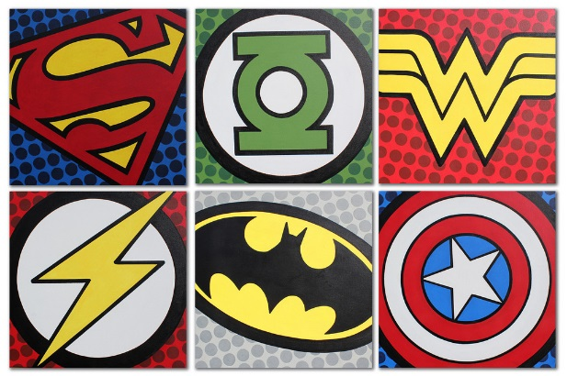
Y2 Learning Log – Spring 1
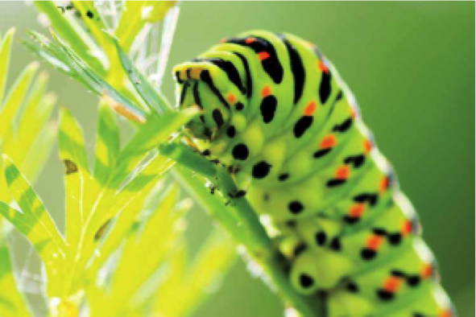
The grid below shows activities for Y2’s topic of “Wriggle and Crawl”.
Homework is due back by Monday 3rd February.
The key skills children will be developing:
Research: Finding information about minibeasts through using the internet, non-fiction texts and by exploring the local area.
Literacy: Writing stories and information texts; reading a range of different texts.
Mathematics: Finding fractions of an amount, using addition and subtractions facts and solving word problems using the four operations.
Science: Learning about animals and noticing that animals have offspring which grow into adults.
Creative: Developing and exploring a wide range of art and design techniques to represent their own world and experiences.

Design and Make  - Can you create a micro-habitat for a minibeast using materials that you find at home, in your garden or your local park? Use this link to help you: https://www.woodlandtrust.org.uk/naturedetectives/blogs/nature-detectives-blog/2017/08/build-a-bug-hotel/  - Design your very own minibeast! What would you call it? What habitat would it live in? What colours and patterns might you see? Make a scrapbook to share in class.  - Look at the work of the artist Don Balke. Can you create a painting in his style? Google ‘Don Balke’ to find examples. | Creative Writing  - Write a description about your favourite minibeast. Can you include adjectives and at least one expanded noun phrase?  - Write a letter to your teacher explaining why she shouldn’t be afraid of spiders. Can you persuade your teacher to change their mind and get a class minibeast pet?!  - Read ‘Norman the Slug with a Silly Shell’’ by Sue Hendra. Can you create a fun minibeast of your own and write your own story to read in class?  - Create an acrostic poem using M-I-N-I-B-E-A-S-T. Illustrate it, too! | Research  - Visit your local library, The Curve, to find stories, poems and non-fiction books about minibeasts. Write a review of your favourite piece of literature and share with your friends.  - Download and print a large image of a minibeast. Label each body part and write what it’s for.  - Research one of these weird and wonderful minibeasts: a thorn bug, an Australian walking stick or a Brazilian treehopper. What is so special about them? Create a non-fiction book including a title, sub- headings, a contents page, an index and diagrams.
Fun Maths  - Create a pictogram showing how many minibeasts you have found in your local park, woodland or garden.  - Design and create a minibeast using 2-D and 3-D shapes and symmetrical patterns.  - During a bug hunt, observe the movement of minibeasts: is there logic in where they are heading? Is there an obvious network of paths or holes (underground paths) which the creatures are using or is it a random approach? Refer to the position and movement of the bugs: when they turn left, right, move forwards, backwards, etc. Use the language of position and lots of prepositions. | Wider World  - Watch Antz, A Bug’s Life or Bee Movie with your family. Then make a comic strip that shows your favourite part of the film or write a review and include a star rating!  - Using this video to help you: https://www.youtube.com/watch?v=26guG6wr5so. Can you create your own animal dance routine? Ask a family member to take photos of your routine to share in class!  - Go on a minibeast safari with your family! Investigate your local park, woodland or garden. Take photos or make observational drawings of any minibeasts you find. | Be a Scientist  - Label and draw the life cycle of either a worm, frog or butterfly. Use the internet or books to help you with this.  - Create a fact file about a frog’s habitat. Present your findings to your friends.  - Investigate how bees make honey. Can you explain to the class how they do this? Why is this process so important? Use the internet or books to help you.  - What minibeasts do you find in the following habitats: the arctic, rainforests, deserts and the ocean? Create a factfile for each one.

