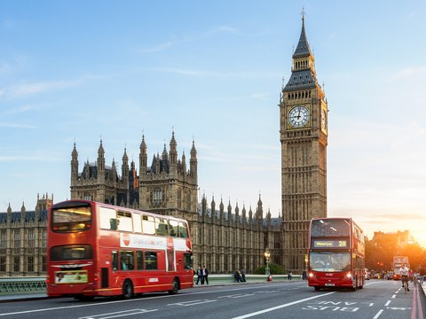
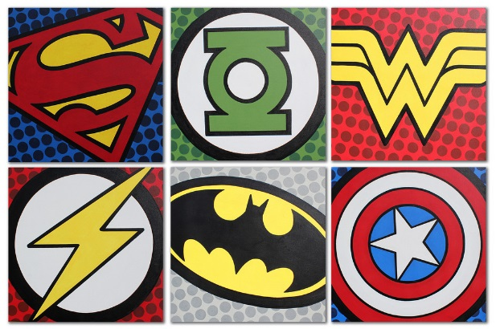
Year 1 Learning Log – Spring 1
The grid below shows activities for Year 1’s topic of “Bright Lights, Big City”.
Homework is due back by Monday 3rd February.
The key skills children will be developing:
Research: Finding out a range of information from the internet and other sources.
Literacy: Writing lists and letters. Reading a range of texts to support research.
Mathematics: Exploring measurement and number.
Science: Scientific enquiry, data collection and recording surrounding engineering.
Creative: Developing and exploring a wide range of art and design techniques to represent their own world and experiences.

Design and Make  - Create and label a picture or map of a fantasy city. What type of buildings would be in your city and what would they look like? What transport would people use in this city?  - Build a real or fantasy city using Lego, blocks or 3-D junk material from home. Play with your city using figures and vehicles. Take photos and create a book to share!  - Design a house suitable for the Queen. What type of house would she need? How many rooms would the house have? What colours do you think the Queen likes?  - Design a healthy packed lunch to take on a visit to London. Can you make it using collage materials? | Creative Writing  - Create a song about a city to the tune of The Wheels on the Bus. Your song should start with, ‘I went to the city, and I saw a…’ Can you write it down so all your friends can join in?  - If you were King or Queen for the day what would your royal rules be? Write a list!  - Write a letter to the Queen inviting her to visit your school. How would you persuade her to come? What would you show her? What would she eat for lunch?!  - Describe your perfect holiday. Which city from around the world would you visit and why? Can you write a postcard remembering to use adjectives and including capital letters and full stops? | Research  - Search the web with an adult to find images of different cities from around the world. Create a scrapbook of your favourite cities and include pictures, labels and captions. Can you find and record a short fact about each one?  - Search the web to find real images of London landmarks. Then save these photos and create your own book all about buildings.  - Ask several members of your family and friends what their favourite city is. Collect the information and then create a pictogram showing your results.  - Create a scrapbook all about the Great Fire of London. When did it take place? What happened?
Fun Maths  - Research some popular tourist attractions in London, for example London Zoo and The London Eye. How much does it cost for adults and children to enter? How much would it cost for your family to go for the day?  - Stage your own London 2012 Olympics in your garden or local park! Time your family members as they compete in events including running races. Who’s the fastest runner? Who can throw the furthest? Can you create a scorecard? | Wider World  - Visit London with your family. Look out for interesting buildings that are different sizes and shapes. Make a list of the sights, sounds and smells that you discover. Draw a simple map of your journey and keep a diary of your day.  - Visit your local library and find some information about London. What interesting facts can you discover?  - Visit another city in the UK. How is it the same as where you live? How is it different? Make a poster to share. | Be a Scientist  - Give yourself 10 mins to build a tall tower using Lego or bricks. Roll a toy car down a ramp into the building. Did it stay standing or did it fall? Why do you think that was? Does shape affect stability? Build some different shaped buildings to find out and take photos to share with your class.  - Can you build a car using construction materials? Let it go down a ramp. How far does it travel? How can you make it go further? Hint: experiment with the size of 2 of the wheels!!

