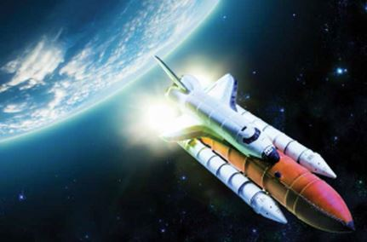
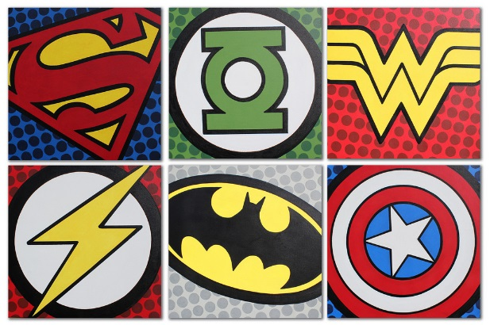
Year 1 Learning Log – Autumn 2
The grid below shows activities for Year 1’s topic of “Moon Zoom.”
Homework is due back by Monday 2nd December.
The key skills children will be developing:
Research: Finding out a range of information from the internet and other sources.
Literacy: Writing stories, captions and poems; reading a range of different texts.
Mathematics: Exploring time and space.
Science: Describing properties of material using everyday language.
Creative: Developing and exploring a wide range of art and design techniques to represent their own world and experiences.

Design and Make  - Make a telescope using a variety of materials. At night, use your telescope to look at the sky. What can you see? You could record what you can see as a drawing, painting, collage or diorama.  - Can you make a model of your own alien? Think about what colour, texture, size and shape it will be.  - Use materials you can find in your recycling bin to make a rocket, spaceship or helmet. What materials are best, and why? How are you going to decorate what you have made? When you have finished, look at what you’ve made and think about what went well, and what you could’ve improved.  - Make a model of the Solar system. Can you order the planets? | Creative Writing  - Imagine you are an astronaut completing a mission in space! Write in your diary. What are you wearing? What are you eating and drinking? What is your mission? How did the journey to space go in your rocket? How long will you be away for?  - Can you create your own story about space? Will it be a story about an alien, an astronaut or another character entirely? If you are stuck for ideas, think about the stories we have learnt in school, and try to innovate it with your own setting, characters and problem.  - An alien has just crash-landed on earth, and he does not know how to do anything! Can you write him some instructions to explain how to get dressed, wash his hands or brush his teeth? | Research  - Come up with some questions that you would like to research – see if you can use one of the ways below to find out the answers:  - Visit the library with an adult and look at books about the solar system.  - Use kiddle.co to research space by typing in your question.  - Ask adults you know, and see what they can tell you about space!  - Find out the names of the people who have walked on the moon. Who was the first person to walk on the moon?  - Gather fascinating space facts and make your very own non-fiction space fact book! Alternatively, make a poster of all the facts you have discovered to display in school.
Fun Maths  - Imagine you are going on a trip to Mars. How long will it take to get there? How long will a return journey take?  - How far away are the planets in our Solar system from the Sun? Which planet is nearest to the Sun? Which planet is furthest away from the Sun? Draw a picture to show the planets orbiting the sun. | Wider World  - What did Tim Peake do when he worked in the International Space Station? Visit the Science Museum in London to find out more and take pictures of your day out.  - Can you track where the International Space Station is over the Earth? Download ‘ISS Spotter’ and track its journey on a World map. | Be a Scientist  - Make a rocket that launches into space! Use this link: https://www.wikihow.com/Make-a-Diet-Coke-and-Mentos-Rocket  - Can you make glittery space slime? https://theimaginationtree.com/easy-uk-slime-recipe-contact-lens-solution/. Take photos of what you are doing and write the instructions so others can follow them.

