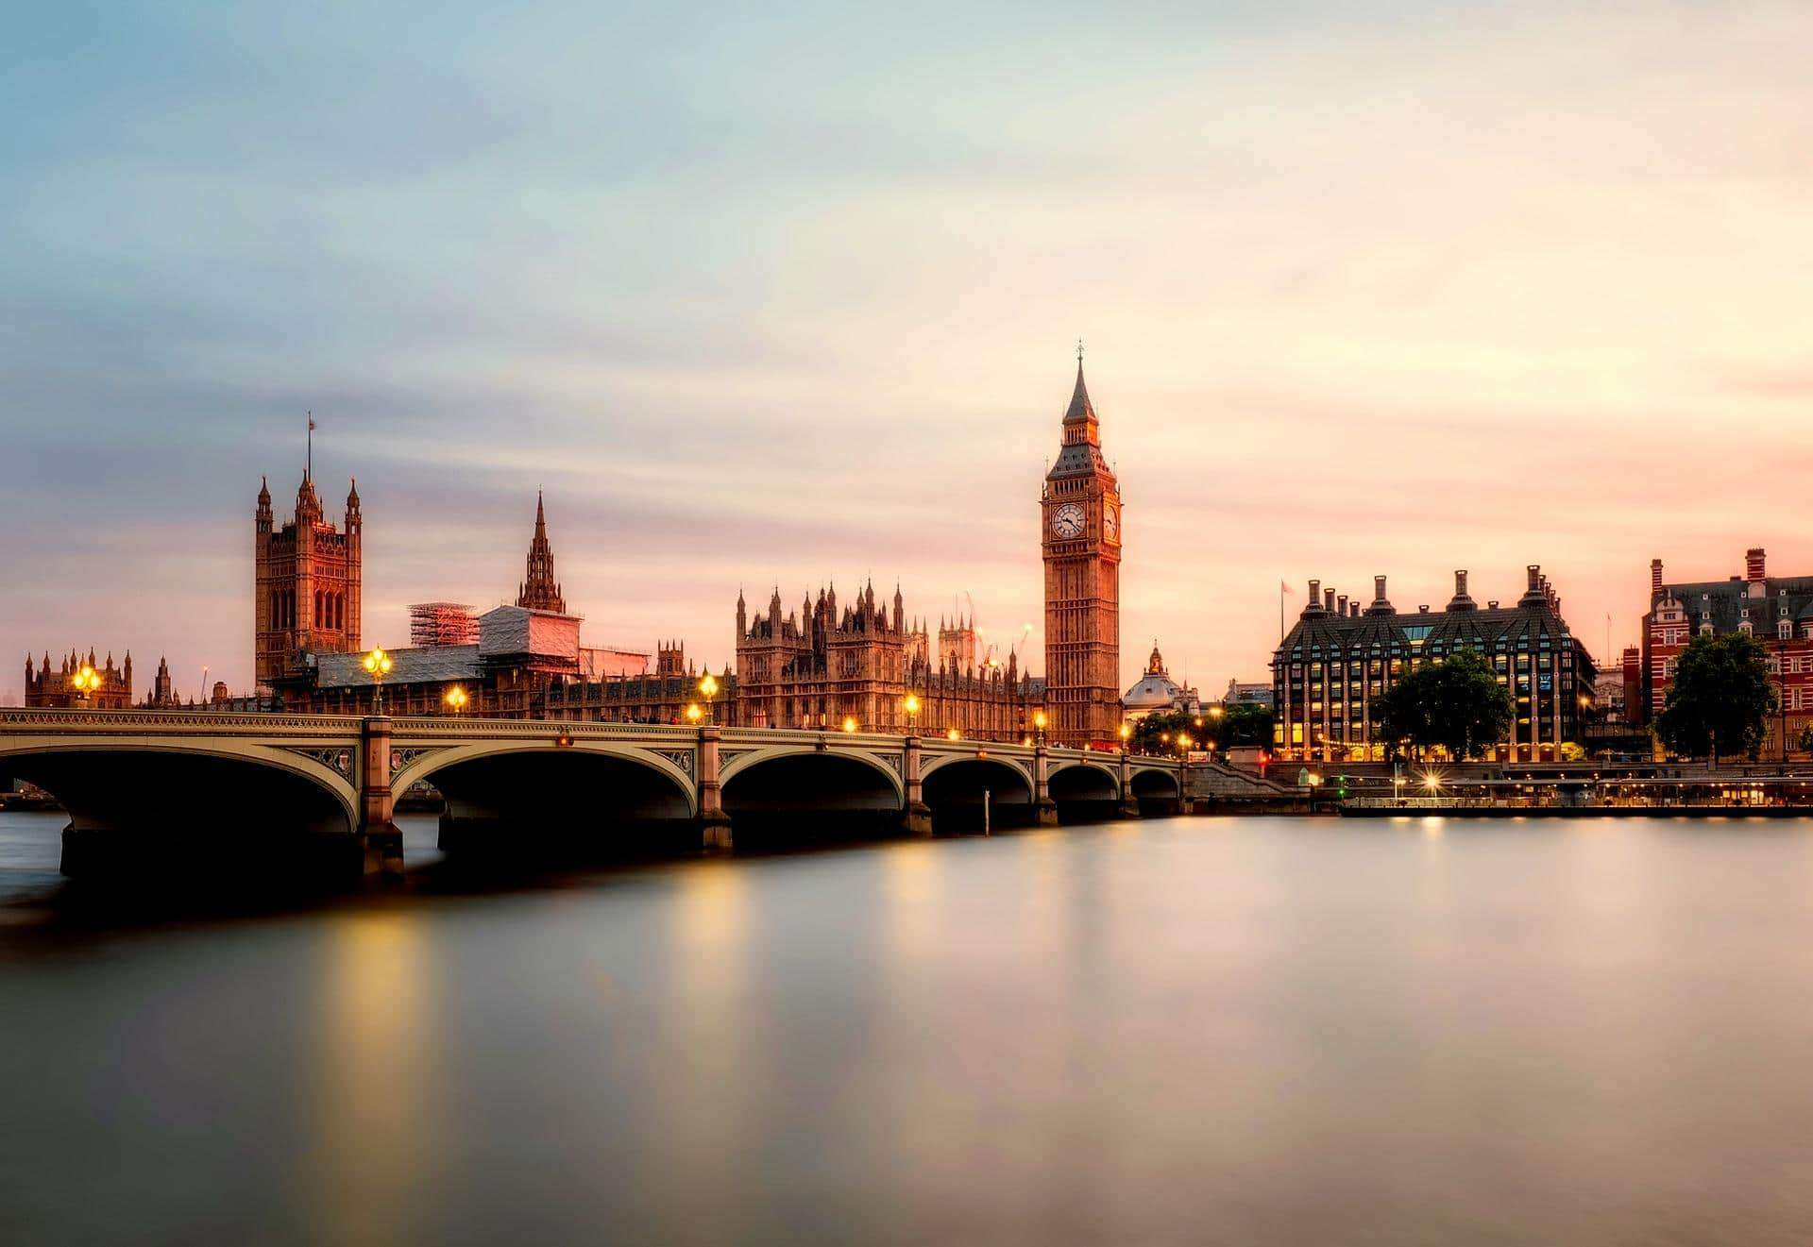

**Design & Technology**

* Exploring landscapes( London), Look at Leonid Afremov’s work and design an element of a city landscape e.g. sky scraper, Big Ben, The Curve
* Select different materials to make the creation thinking about ways of joining different sections together.
* Look at different buildings in the local area (Tesco, Mosque, Gurdwara). Children to design their own building from the local area using different textiles (paper, card, fabric etc.). Children to evaluate their designs.

Vocabulary - tall, round, strong, paint

**Geography**

* Use basic geographical vocabulary to refer to key physical features.
* Use world maps, atlases and globes to identify the U.K and its countries as well as countries, continents and oceans.
* Use simple compass directions (north, east, south and west) and locational and directional language; near, far, left and right, to describe the location of features and routes on a map.
* Use aerial photographs and plan perspectives to recognise landmarks and basic human and physical features.
* Devise a simple map and use and construct basic symbols in a key.
* Use drawing, painting and sculpture to develop and share their ideas, experiences and imagination.

**History**

Historical Question

* Children will ask and respond to simple questions about the past, using sources of information.

Historical Enquiry

* Children will use simple source material (e.g. photographs) to answer questions about an event beyond living memory.

Vocabulary – Children will use simple vocabulary to describe passing of time e.g. now, then, long ago, before and after.

**Art & Design**

* Explore different materials and mixing paint to suit a task
* Exploring different forms of art eg observational drawings, collages etc.
* Selecting different colours and materials to create their 2D or 3D images/structures to represent bright lights –

big city structures, Great Fire of London

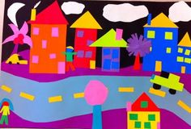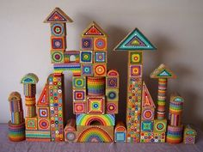

Looking at and drawing inspiration from Van Gogh’s work of art e.g the starry night to paint own pictures.

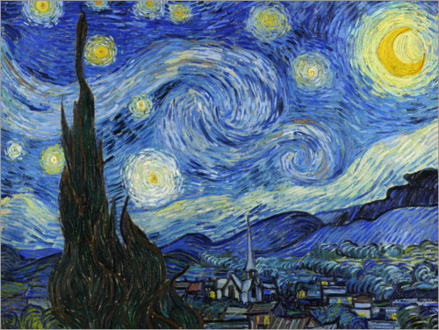

* Talk about successes and challenges encountered in completing their piece of Art. Comparing their work and sayng how they can improve it.

Vocabulary - design, structures, 2D, 3D,

**Knowledge, Skills and Vocabulary**

**Bright Lights, Big City**